4. Test your responsive product card by resizing your browser window and taking screenshots at mobile, tablet, and desktop widths; submit the screenshots along with a short note on what changes at each size.
Mobile: around 375px width
- Image appears on top
- Product details appear below
- Smaller fonts and padding
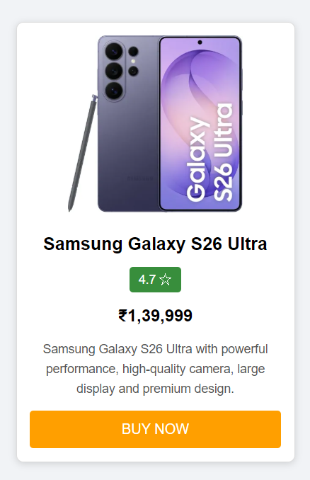

Tablet: around 768px width
- Image and details remain side by side
- Medium image, font size and padding
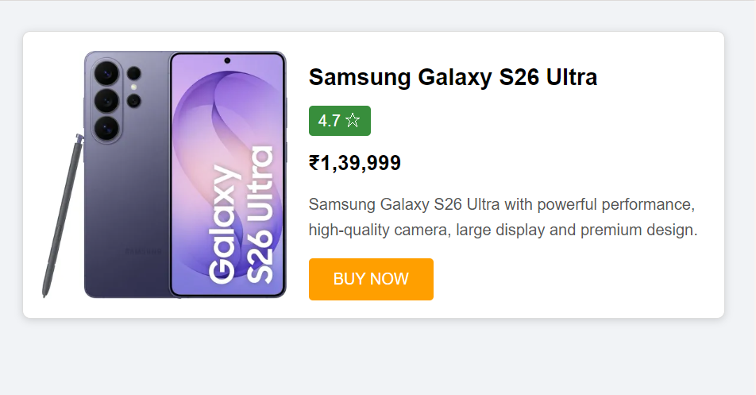

Desktop: around 1366px width
- Image and details remain side by side
- Larger spacing and fonts
